© Copyright Broadsword Interactive 1998

Racing Line File Format
Describes the format of a racing line set file

Jim Finnis (jcf@broadsword.demon.co.uk)
Revision: 1.2

Created: 17/12/98
Last Revised: 17/12/98
Document State: Draft

Overview
This document describes the format of a racing line set file.

In Spirit of Speed, a racing line describes the course an AI car (and a player car) should take around the track. It also contains information about which speed should be taken.

The file consists of a set of racing lines. Each racing line describes a different course around the track. Most tracks will only have a single racing line in the set, the exceptions being tracks like Brooklands where the first and last laps go round a different course – in this case there will be three racing lines in the set.

Each “racing line” within a set, however (and somewhat confusingly), contains a number of seperate, parallel lines made up of sets of points. There’s the same number of points in each of these lines. There are usually three lines – a centre line, and two lines either side for when a car needs to overtake.

Note, therefore that racing line usually refers to a group of lines.

The format of the racing line set file is as follows:

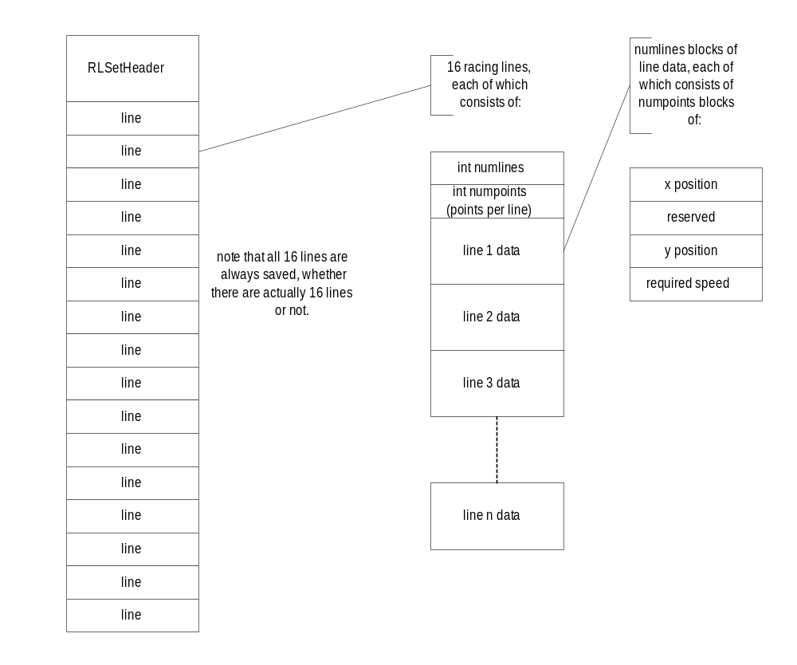
The RLSetHeader structure is as follows:

struct RLSetHeader
{
unsigned long magic; // magic number – must be 0xdeadbeac
short numlines; // the number of lines used
short haswalls[16]; // which of the lines have walls (see below)
};

The haswalls field is a set of booleans which says which of the racing lines have walls defined.If haswalls is true for a given line, then the last two of the lines defined for that racing line are actually walls (left and right respectively), which the AI should know how to avoid.

